1. Explain following terms:

- Capital budgeting: This is the act of analyzing profitability and deciding to execute or reject new business decisions.

- Depreciation : This is the cost of allocating and disposing of purchased depreciable assets from the time of purchase to the time of use.

- Opportunity costs: When someone choose something, it's the most valuable alternative someone have given up.

- Cannibalization: New products and technologies released by one company break into other products and technologies previously sold by the company, and have a negative impact on sales.

- Sunk costs: After paying it, it is a cost that cannot be recovered.

- Free cash flow: surplus money after investing money into necessary areas

- Net working capital: capital used to run a company

- Depreciation tax shield: a tax reduction technique under which [depreciation expense](https://www.accountingtools.com/articles/2017/5/6/depreciation-expense) is subtracted from [taxable income](https://www.accountingtools.com/articles/2017/5/15/taxable-income).

- Tax loss carryforwards/ carrybacks: the practice of treating a company's present profit or loss as if it happened in a later period / If the total amount subject to a tax deduction in a tax year exceeds the total amount of the deduction limit for the year, the tax paid in the past has been refunded.

- Sensitivity Analysis:

2. What is the project’s break-even point?

The break-even point is that sales in a period are consistent with the total cost in that period. The analysis will examine the relationship between sales and fixed costs and variable costs.

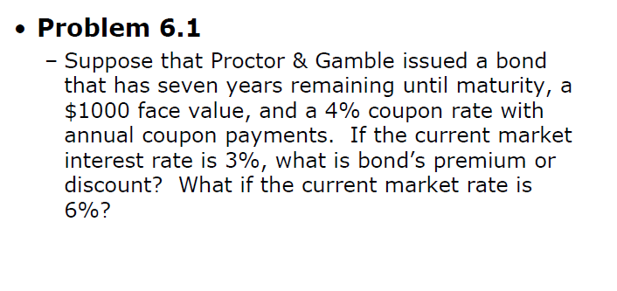

Bond FV : $1000 * 0.04 * 7(bond’s incoming profits) + $1000(bond’ face value) = $1280

FV, when interest rate is 3% = $1000 * (1.03)^7 = 1229.8……

$1280 > 1229.8….. ∴bond’ premium.

But if market rate is 6 %, 1000 * 1.06^7 = 1503.6… ∴bond’ discount.

